For the printing preferences:
For Normal printing:
- Change the printing preference settings ( Go to Control Panel Device & Printers right click on Printer and Select Printing Preferences )

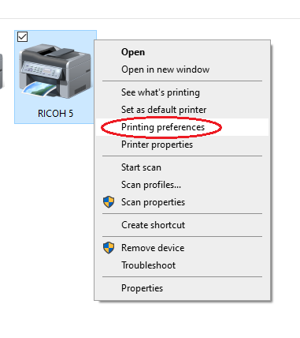
- Select preferred Job Type , Document Size , Orientation , Paper type and 2sided or not.
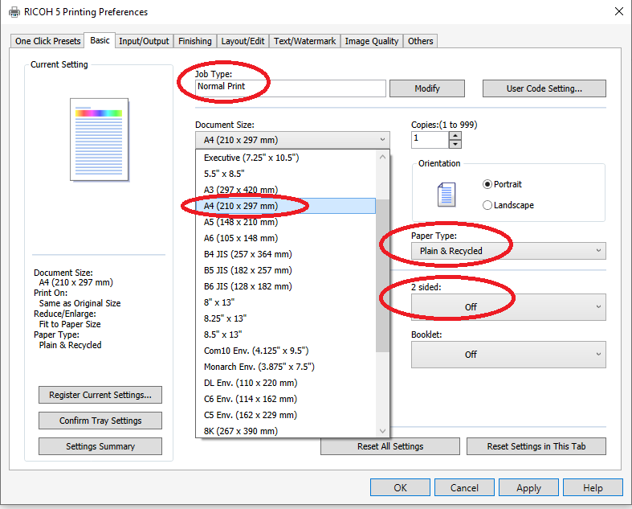

3.Click “Apply” and click “OK”.

For Locked printing
- Change the Job type to Locked Print in the Printing Preferences(Click on the “Modify” button or in drop down menu).
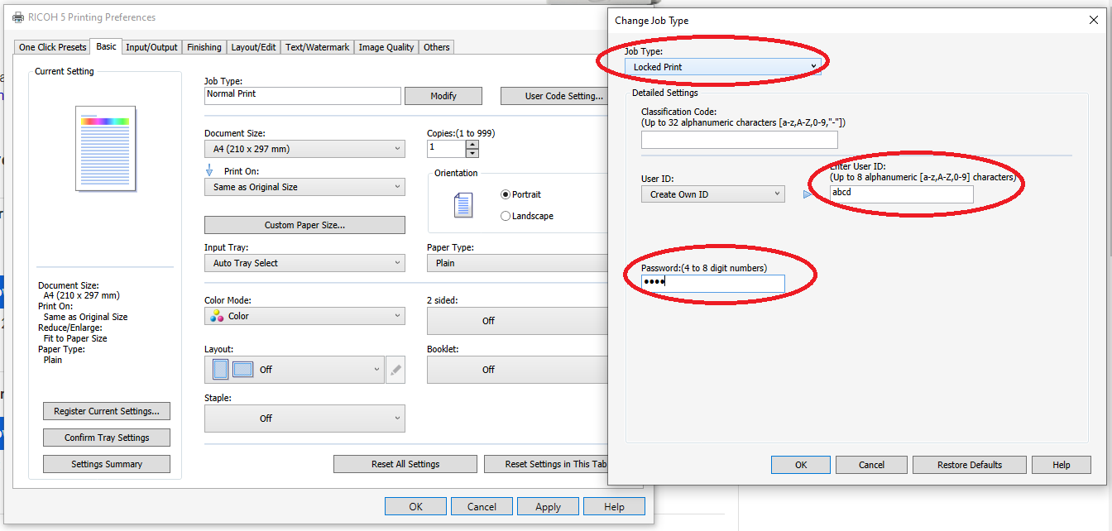

- Enter the User Id and Password as per your preference then Click “OK”.

